Burgers with Roasted Garlic and Rosemary

* [Nutrition](http://www.teambeachbody.com/teambeachbodyblog/category/nutrition)

* [Recipes](http://www.teambeachbody.com/teambeachbodyblog/category/nutrition/recipes)

May 21, 2015

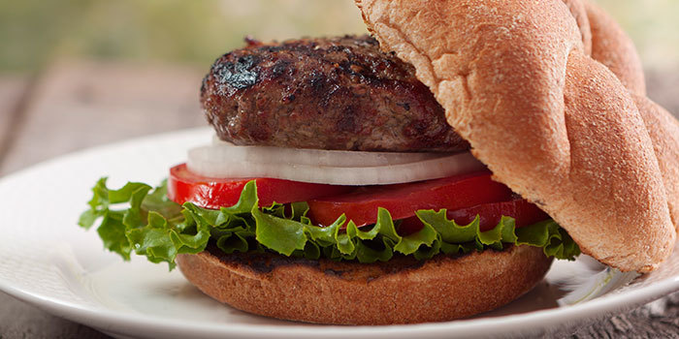

Roasted garlic and fresh rosemary make these burgers extra flavorful. Adding grated zucchini to the lean ground beef helps keep the burgers moist, and is an inexpensive way to add bulk. It’s almost undetectable, so it’s a clever way to sneak extra veggies into your diet. If you like the zucchini, experiment with adding a second grated zucchini! Try this with turkey burgers, too.

**Total Time:** 1 hr. 17 min.  
**Prep Time:** 10 min.  
**Cooking Time:** 1 hr. 7 min.  
**Yield:** 4 servings

**Ingredients:**  
1 whole garlic bulb  
1 lb. raw 95% lean ground sirloin  
1 medium zucchini, coarsely grated  
6 fresh rosemary sprigs, leaves removed and finely chopped, stems discarded  
¼ tsp. sea salt  
½ tsp. cracked black pepper  
4 whole-grain hamburger buns  
4 slices medium tomato  
4 lettuce leaves  
4 red onion slices

**Preparation:**  
1. Preheat oven to 400° F.  
2. Remove outer papery white layer from garlic, keeping each individual clove covered, and keeping cloves attached to the bulb. Cut off top ½-inch of bulb. Place on a piece of aluminum foil; wrap to completely seal. Bake for 45 minutes, or until tender.  
3. Preheat grill or broiler to high.  
4. When cool enough to handle, peel away foil from garlic. Squeeze garlic into a large bowl.  
5. Add sirloin, zucchini, rosemary, salt, and pepper; mix well. Shape mixture into four patties.  
6. Grill or broil patties for 4 to 6 minutes on each side, or until desired doneness.  
7. Top each bottom bun with a patty, tomato slice, lettuce leaf, onion slice, and top bun.

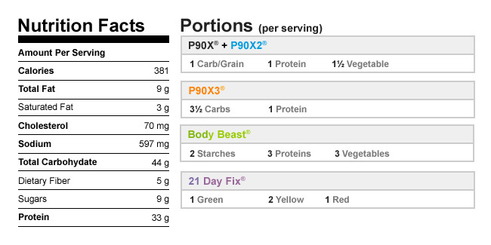

Authors

[Beachbody](http://www.teambeachbody.com/teambeachbodyblog/author/beachbody)

Tags[beef](http://www.teambeachbody.com/teambeachbodyblog/tag/beef), [burgers](http://www.teambeachbody.com/teambeachbodyblog/tag/burgers), [dinners](http://www.teambeachbody.com/teambeachbodyblog/tag/dinners),[high-protein recipes](http://www.teambeachbody.com/teambeachbodyblog/tag/high-protein-recipes),[lunches](http://www.teambeachbody.com/teambeachbodyblog/tag/lunches), [recipes](http://www.teambeachbody.com/teambeachbodyblog/tag/recipe),[sandwiches](http://www.teambeachbody.com/teambeachbodyblog/tag/sandwiches)

RELATED POSTS